Changing the code in the Arduino Evaluation Kit to Data log over the USB/Serial Port

The Arduino Uno compatible used in the Advanced Sensors Evaluation kit has insufficient capacity to concurrently display and send values to serial port, so they need be ‘switched’ in the software. Both options are available in the sketch, a simple modification to the code allows this to be changed.

Download and install the Arduino IDE from Arduino.cc

Set up a directory ‘Arduino’ in your ‘My Documents Folder.

From <https://github.com/AmphenolAdvancedSensors/Evaluation_Kits/tree/AAS_AQS_UNO_RH_CO2> download all files into My Documents/Arduino/TelaireSensors directory.

From within the directory TelaireSensors, double click the TelaireSensors.ino file, this should open the file in Arduino IDE program.

Plug in the Arduino Evaluation Kit to be modified.

In File >Preferences ensure your Sketchbook location is set to the folder you created (C:\Users*your local name*\Documents\Arduino)

Check the Board under ‘Tools’ is set to Arduino/Genuino Uno

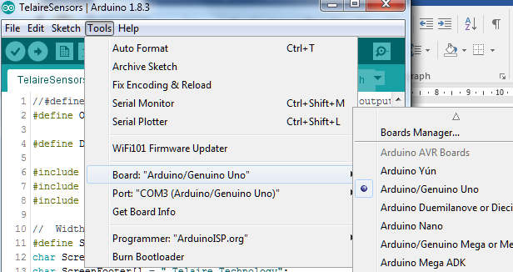

Check your port is connected.

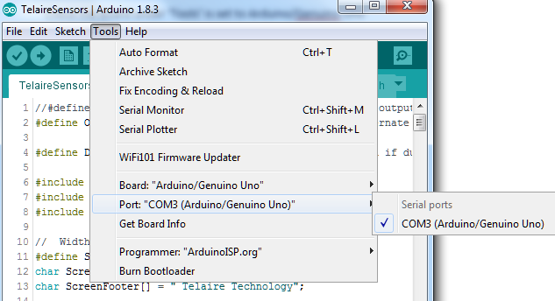

Check the Adafruit SSD1306 Library is installed. And install if it is not. Go to Sketch > Include Library > Manage Libraries

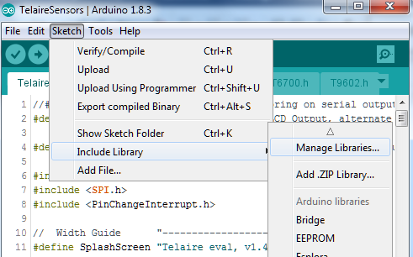

Index will be created (this may take a little time, watch bar at bottom)

Filter Adafruit SSD1306, if it is not there, add latest version.

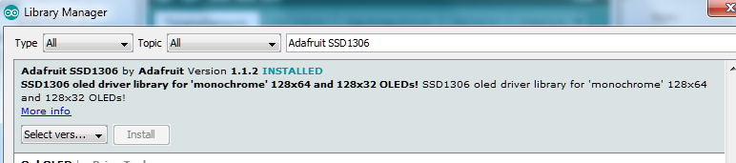

In Windows Explorer go to My Documents>Arduino>libraries>Adafruit SSD1306 and open Adafruit_SSD1306.h with NotePad (Open With Command on Right Click)

Scroll down until you find:

/*=========================================================================

SSD1306 Displays

-----------------------------------------------------------------------

The driver is used in multiple displays (128x64, 128x32, etc.).

Select the appropriate display below to create an appropriately

sized framebuffer, etc.

SSD1306_128_64 128x64 pixel display

SSD1306_128_32 128x32 pixel display

SSD1306_96_16

-----------------------------------------------------------------------*/

#define SSD1306_128_64

// #define SSD1306_128_32

// #define SSD1306_96_16

The last 3 lines should look as they do here, if they don’t, change them so they do.

The PinChangeInterrupt library also needs to be added.

Go here: <https://github.com/NicoHood/PinChangeInterrupt> and follow the instructions there. Once installed it can be checked in your Library Manager (Sketch > Include Library>Manage Libraries)

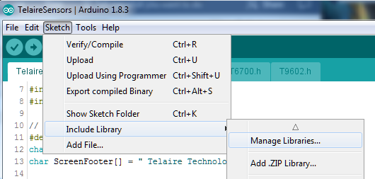

Search pinchangeinterrupt.

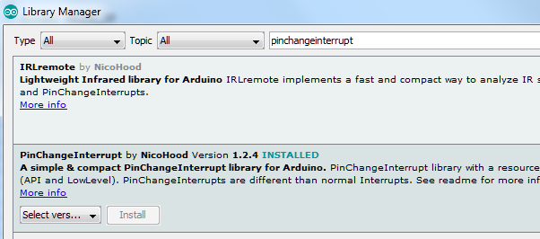

Close the library window.

To verify all is OK press the tick. cid:image004.jpg@01D30243.D7BC90C0, the sketch (program) should compile without errors

To modify the sketch to send values to the PC rather than display them on the OLED then the top lines of code need be modified from default:

//#define USB //enable or disable monitoring on serial output, alternate with display, 115200 baud

#define OELCD_OP //enable or disable LCD Output, alternate with serial output

To:

#define USB //enable or disable monitoring on serial output, alternate with display, 115200 baud

//#define OELCD_OP //enable or disable LCD Output, alternate with serial output

This remarks ‘out’ the OLED and remarks ‘in’ the USB connection. Changing it back reinstates the OLED and switches off the serial output.

Upload (The Arrow pointing right on icon bar). Program should then compile and upload. cid:image004.jpg@01D30243.D7BC90C0

Open the serial window (magnifying glass icon top right) cid:image005.jpg@01D30243.D7BC90C0

Set the baud rate to 19200 in the bottom right, and you should see something like this:

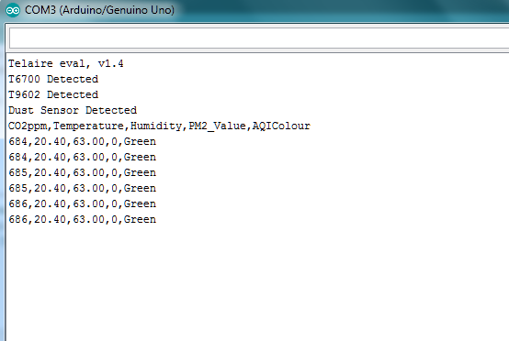

The values are now being transmitted to the sriel port and can either be data logged with program like coolterm, or operated on as you wish.

To set the evaluation kit to display values again reverse the commented lines to read as default:

//#define USB //enable or disable monitoring on serial output, alternate with display, 115200 baud

#define OELCD_OP //enable or disable LCD Output, alternate with serial output

This remarks ‘in’ the OLED and remarks ‘out’ the USB connection. The software sketch then needs to be downloaded to Arduino.